Questions to think about:

**Part 1: Edward**

**How does Singapore portray community policing?**

(Many different types of volunteering not limited to the list)

1. Volunteer Special Constabulary (VSC)
2. Volunteer Special Constabulary (VSC) (Community)
3. Citizens On Patrol (COP)

Other than VSC, the role of community policing is mainly to patrol a designated area and to help detect crime in their designated area of patrol. Community police can help to deter crime by disseminating crime prevention advisories but are expected to report to the Police if they encounter any suspicious persons or any crime in progress.

**What is Singapore’s rationale for community policing?**

To help engage the public by participating at community events and roadshows, as well as disseminating crime prevention advisories to the community during their patrols. The deployment of community police personnel, equipped with standardized and easily recognizable uniforms and tools such as handcuffs, serves to project a robust and unified presence of authority. Community police are envisioned as contributing to the "net strengthening" of surveillance mechanisms (). Through the involvement of citizen volunteers in patrolling and community engagement activities, this can help reduce manpower constraints of law enforcement agencies, enhancing the state's capacity to monitor their citizens and maintain social order.

Community policing can also serve as a

* Jarmal Singh, “COMMUNITY POLICING IN THE CONTEXT OF SINGAPORE”
  + Overview of the founding and history of “the Neighbourhood Police Post (NPP) system in 1983 and the shift towards community-focused policing through the creation of Neighbourhood Police Centres (NPCs) in 1997”

**Who is the ‘ideal’ recruit for community policing?**

COP - “SPF is looking for volunteers who are passionate and keen to contribute to the safety and security of their community. We welcome Singaporeans and Permanent Residents, between the ages of 17 to 80 years, to apply for the COP scheme”

**Part 2: Erika, Shuyi**

**What is the reality of community policing? What benefits and harms does community policing have on the communities themselves?**

Role of community policing

* Maintaining social order rather than in the direct control of crime -- disorder undermines the processes by which communities ordinarily maintain order informal social control system
* Bridges the 'criminological gap' that exists between the realist and administrative criminological perspectives on the police role.”

→ Singapore’s perspective to crime: right realism -- anti-social behavior as the product of anti-social circumstances.

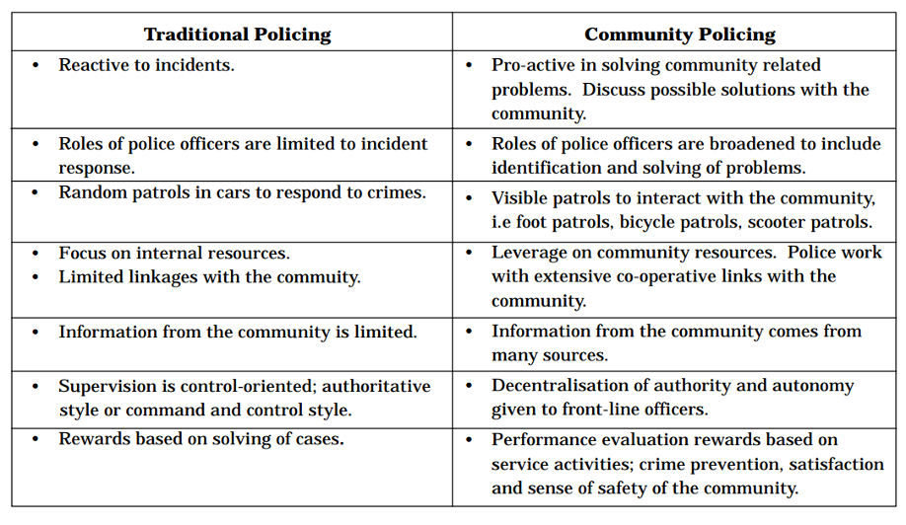

Some key points:

1. Change of approach – from reactive, incident driven policing to proactive approach -- prevent crime before it can occur

2. Decentralization of police functions from the divisional level to neighborhood level

a. Greater anatomy for the police

b. Able to penetrate deeper into the society, thus effectively preempt criminogenic conditions

3. Enhanced police-citizen relationship -- Police is closer to the community

a. More visible in the neighborhoods, better deter crimes and eliminate the general fear of crime in society

4. Increase public awareness of crime prevention and their responsibilities

Community policing from volunteer’s perspective (VSC)

Benefit

- As the reserve ranks of the police force

o VSC supplements regulars in the performance of all sorts of community/policing duties -- highly effective in emergency response, security operations et

o Provide police presence on the ground

o ⇒ **On the other hand, it restricted to performing menial and repetitive tasks such as crowd control, traffic control, sentry duties and security escort** --‘second-class policemen’

- Provide **fresh** perspective

o ⇒ **This concept in itself is debatable, and given Singapore as a highly governmentalized state, it is debatable how unique the perspectives of volunteers can actually be**.

- Embodiment of Police Knowledge-in-Action

Draw backs

- Work for less – community policing via volunteering -- volunteers paid very little

- Might not able to learn from accompanying experienced – given the repetitive nature of task they might be assigned to

⇒ “The reasons for joining and remaining within the VSC are not just reflective of specific individual experiences of participating in formal policing work, but are also refractive of social processes through which individuals actively police their personal communities.”

**How does community policing impact different communities? Are there differences in the impact when considering race, socioeconomic background, gender, etc?**

Police force

- Malay minority -- difficulties in the recruitment and retention of high-quality personnel

- Women’s role strictly limited

- Recruitment using scholarship system

- Result in political and military elites’ become socially and functionally integrated, significantly reducing the professionalism of SAF officers.

**Part 3: Everyone!**

**How do Durkheim, Lembrosso, and Beccaria’s theories apply to community policing, if at all?**

Youth -- Boys Clubs, especially designed to target juvenile delinquency during which Singapore experience increasing concern about young offenders and juvenile delinquency

* Theory: expanding the criminalisation process of the police to include even minor public offenses and incivilities that are perceived to have an impact on real crime. → **Durkheim**

Theory: *Social* measures as dealing with the root causes of crime - as in social democratic positivism and Situational measures as involving the manipulation of aspects of the physical environment to reduce criminal opportunities

**Part 4: Crime watch**

The author argued crime watch as state-text – power-relation

- “Crime Watch occupies a unique position within popular culture in Singapore, through its official capacity as an instrument of serialized community engagement of the police”

- Officers taking time off their normal duties to act on Crime Watch enjoy no remuneration – how the state encourage officers to take part in crime watch and